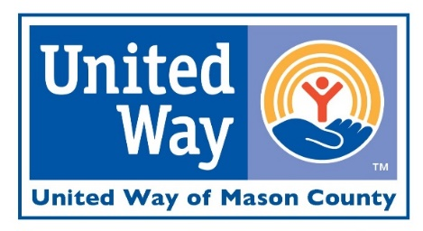

ENDORSEMENT LETTER SAMPLE

Dear Employee:
As CEO of (Company), I am very proud of our company and its employees for helping to make our community better place through participating in United Way of Mason County’s annual fundraising campaign.
Our company believes in the effectiveness, efficiency, and accountability of our United Way. That is why we provide the time and opportunity for our employees to learn about the powerful impact that our United Way is making in Mason County. We also offer the convenience of payroll deduction, which makes it easier to give. In addition, our company provides a corporate gift.
Please give serious consideration to this opportunity and be a part of making a difference in Mason County. Your gift, combined with the gifts of others in the community, will help United Way of Mason County continue to bring together people from all walks of life to find solutions to our community’s most complex social issues. The dates of our company’s campaign are (Dates). Our Employee Campaign Coordinator is (Name), who will be able to answer questions that you may have.
Thank you for helping (Company Name). I believe in their mission and what they do in the community – it’s why I give to them through payroll deduction. Thank you for joining me in making a difference here in Mason County, I’m excited to be UNITED TOGETHER FOR TOMORROW.
Sincerely,
CEO / Manager Name

